**Team Green Project Journal:**

**Assignment: Team 02 Project**

**Completion Date: 4/23/2021**

**Specified Roles:**

Team Leader - Sarah Shoup

Asset Manager - Parker Hague

Documentarian - David Hiltzman

GitHub Repo: <https://github.com/ParkerH98/Team_Green> (Private Repo, so will need to be shared)

**We have supplied an extra commit if you want to see the AR version of our project**

**What we built:**

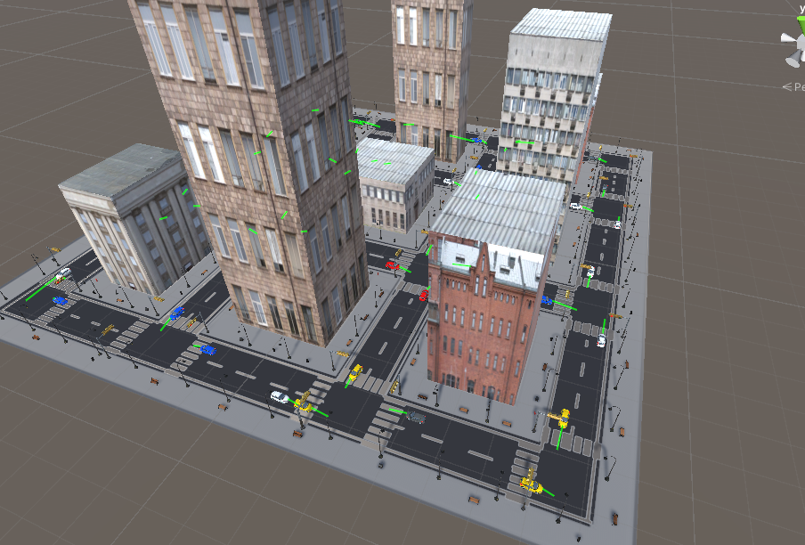

We built a 3x3 block complete with working intersections, automated traffic, and a userVehicle.

It’s a basic plane that has script generated Buildings, traffic, and even decorations are automated.

Roles and tasks assigned:

David - traffic/movement scripts

Parker - 9 buildings

Brayden - add some stationary decorative items & assets

Robby - button to turn on/off the user's car identifier (visible glow is the plan for this)

Sarah - button to display map that will become user input

Simon - implement AR and reticle usage

The roads were created by David and put onto a single plane that the entire project was built on:

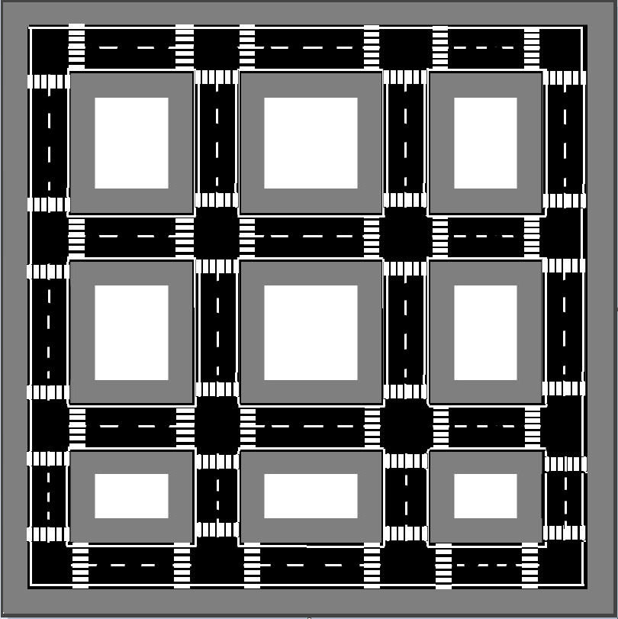

David implemented a Traffic System. The scripts generated automated vehicles that avoided collisions. Two left turns caused a lot of issues, so each intersection goes one stoplight at a time.

Parker created building scripts that picked randomized sizes, and heights for each one every time:

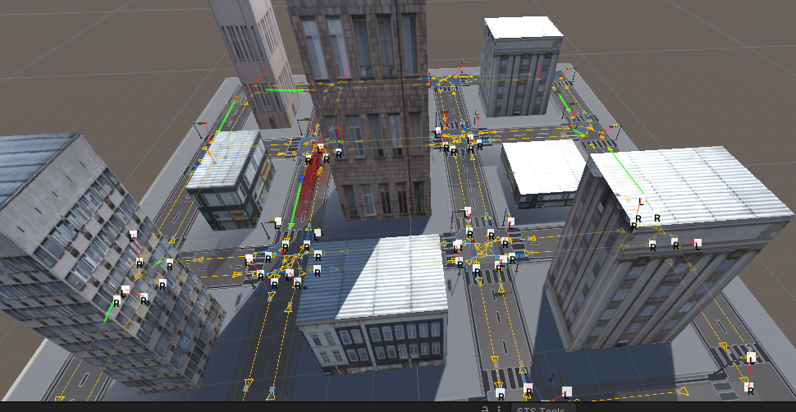

Sarah created the minimap and user vehicle commands:

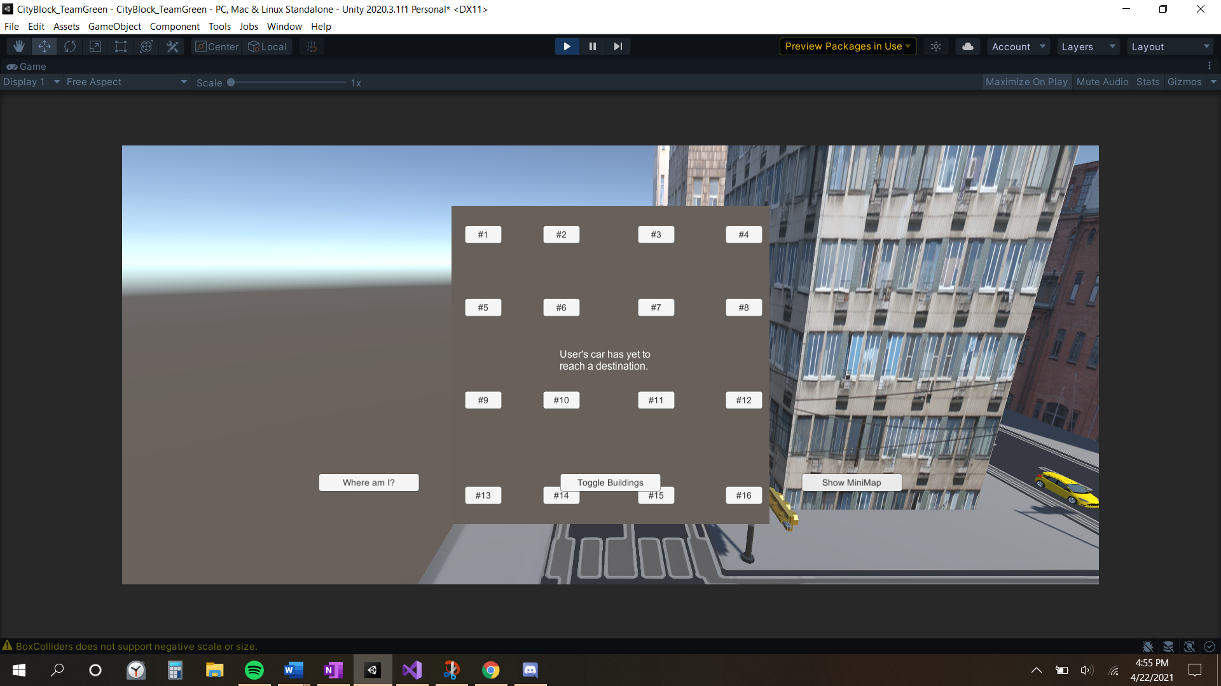

Robby created the randomized decorations. He even implemented a subroutine that only allowed one fire hydrant per block.

Simon implemented the AR reticle and made our system AR capable. Unfortunately his work was unable to be completed. We chose to turn in a project that shows off everyone’s work. I go into later detail further down.

**Workarounds:**

**Due to an ever increasing time crunch, the team elected to use a prebuilt asset to assist with the waypoint creation. This was not an easy decision but David bought the asset (in references pdf) and implemented it into the scene. The userCar also follows a set of Asset Waypoints, but it does what it is supposed to do, in a more roundabout way.**

**Some Reasons for using a prebuilt asset:**

1. **Time**
2. **Complexity required**
   1. **The amount of intersections was massive and David spent two weeks trying to make it work from his own program and designs and ultimately made the decision to move on.**
   2. 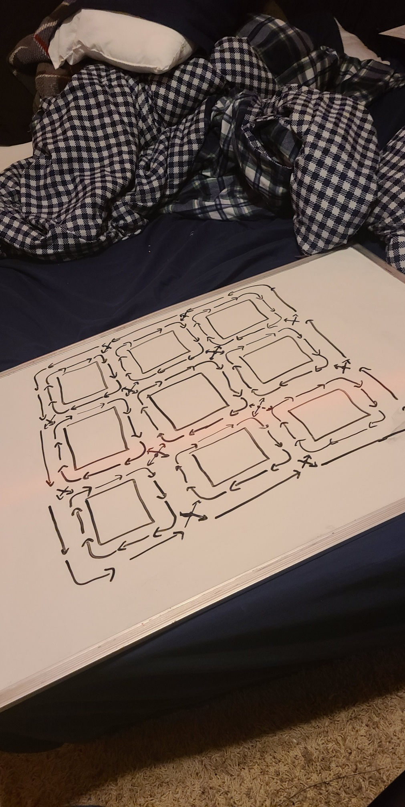
3. **Stoplights and triggers**

**We ask that you take the issues we had into consideration, as well as the financial burden, and not take away too many points for a three man group.**

**Issues we encountered:**

We encountered a LOT of issues with Unity itself. Had multiple crashes, version updates that caused restarts. Git even caused us a lot of headache due to commits not working properly and breaking the scene. Parker couldn’t see the full project for 2 weeks because his Unity was broken on the meta file level.

**The AR Android system ended up not being implemented due to the sizings. When we reduced the sizes to fit the specifications, the waypoints would fail, and cars would not move. We have supplied an extra commit if you want to see the AR version of our project**

The cars would not follow the waypoints when in smaller scales:

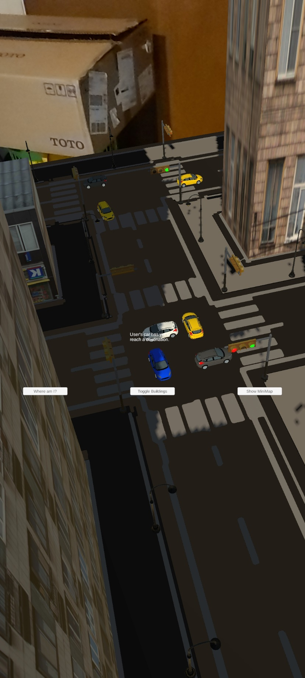

We also found out that the prefab vehicles had sizing issues that would randomly cause them to get larger:

